**What's in a Mini Gardening Kit? High-Quality Gardening Tools**

If you enjoy growing small, charming plants in pots, then you can’t miss the adorable and highly practical mini gardening kits. Let’s explore the features and benefits of these kits with **Green Groves**.

**Overview of Mini Gardening Kits**

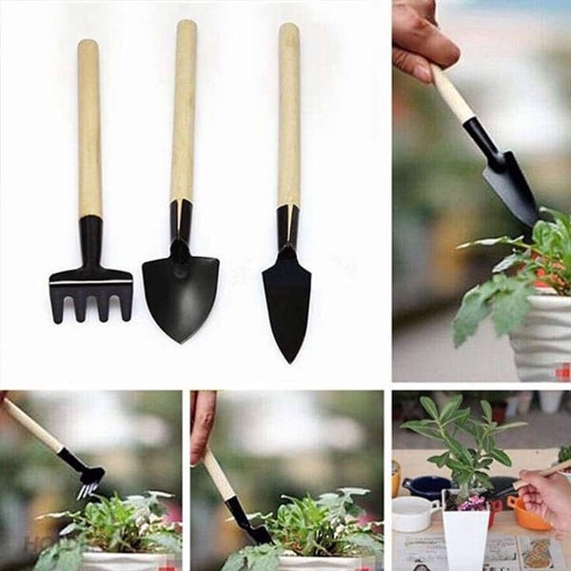

**Common 3-Piece Mini Gardening Kits**

True to their “mini” name, these kits typically include tools of very compact size. Each tool is usually less than 20cm long and fits comfortably in one hand. Despite their small size, the materials used are impressively durable:

* Blade Materials: Tools like hoes, rakes, and trowels are made of iron, coated with an electrostatic paint layer. This coating prolongs the product's lifespan, prevents rusting and warping, and makes cleaning easier after use.
* Handle Materials: Wooden handles are lightweight and ergonomically designed, making them easy to grip and maneuver.
* Plastic Variants: Some products use high-grade plastic, offering diverse colors, easy cleaning, and excellent portability.

**Types of Kits**

* 3-Piece Kits: Usually include a large trowel, a small trowel, and a hand rake.
* 4-Piece Kits: These often add a cleaning brush and a plant clip alongside the standard digging and shoveling tools.

**Benefits of Using a 4-Piece Mini Gardening Kit**

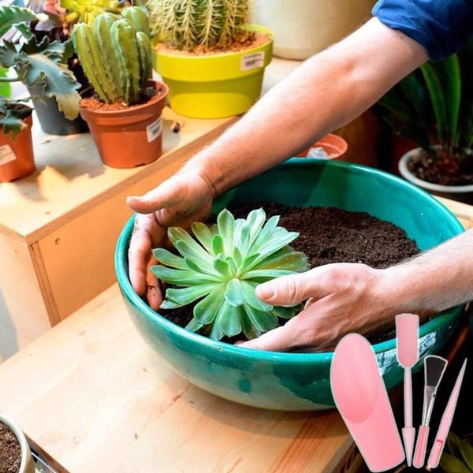

* **Perfect for Small Potted Plants:** The compact size makes these tools ideal for working with small potted plants, such as succulents and cacti, often displayed on desks or shelves.
* **User-Friendly for All Ages:** These tools are lightweight and safe, making them suitable for everyone, including the elderly, children, or those with limited hand strength. The risk of injury during tasks like digging or loosening soil is virtually negligible.
* **Easy to Clean and Store:** After use, simply rinse off soil and dust with clean water. For added care, dry them thoroughly and store them neatly in a corner.
* **Encourages Gardening Enjoyment:** The cute, miniature design of these tools adds a fun element to gardening. Using these tools to meticulously care for your plants can bring a sense of calm and satisfaction.

**Where to Find Quality Gardening Tools**

While these mini kits are easy to use, finding a reliable source can be tricky. A highly recommended option is **Green Groves**, a trusted supplier of high-quality gardening tools. Their product range is extensive, offering everything you might need for your gardening passion.

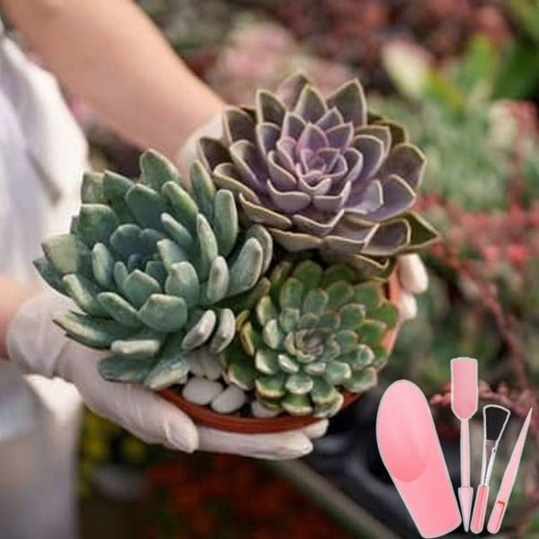

**Green Groves** also frequently runs discounts and promotions, helping you save while indulging in your love for plants and flowers.

Make gardening a joyful and hassle-free experience with **Green Groves**! 🌱